**Cognizant Deep Skilling Mandatory Hands-On Questions**

**TOPIC- Microservices with Spring Boot 3 and Spring Cloud Boot 3 Exercises**

**Exercise 1:** Creating Microservices for account and loan

In this hands on exercises, we will create two microservices for a bank. One microservice for handing accounts and one for handling loans. Each microservice will be a specific independent Spring RESTful Webservice maven project having it's own pom.xml. The only difference is that, instead of having both account and loan as a single application, it is split into two different applications. These webservices will be a simple service without any backend connectivity.

Ans)

Step1) Creation of a Employee folder in D-drive

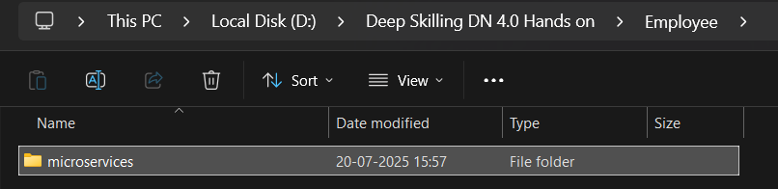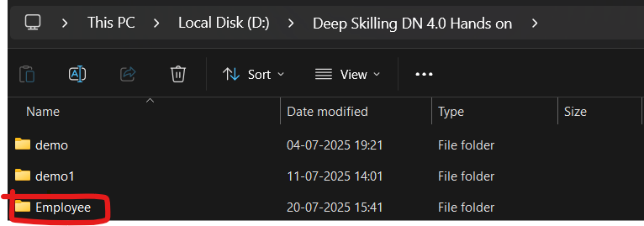

For Account And Loan Microservices

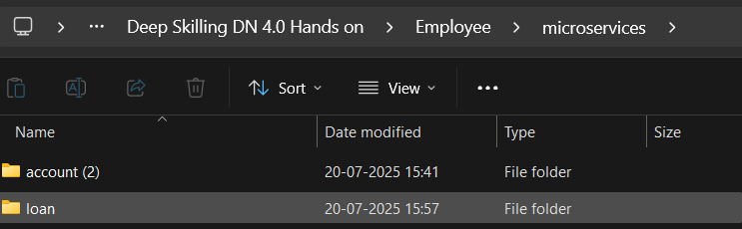

Step 2: After importing the pom.xml file to IDE , Create a class named as AccountController :

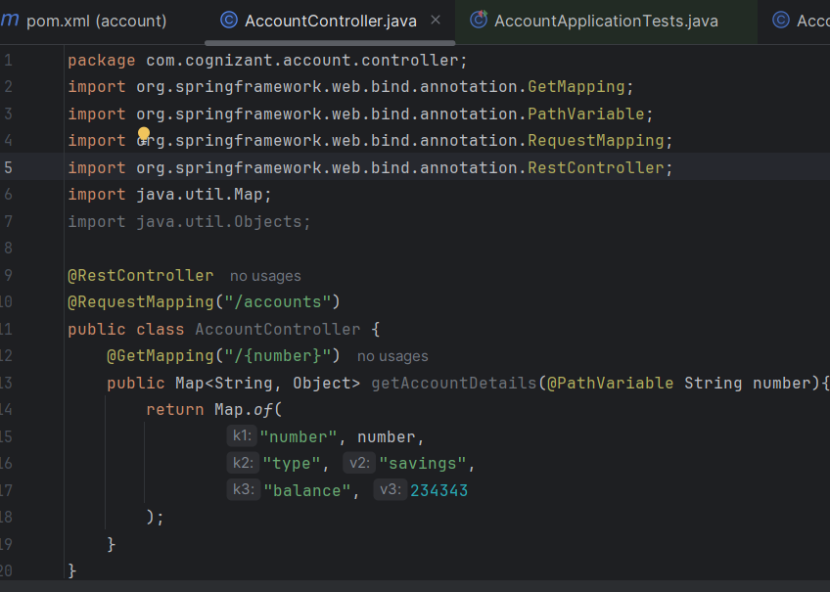

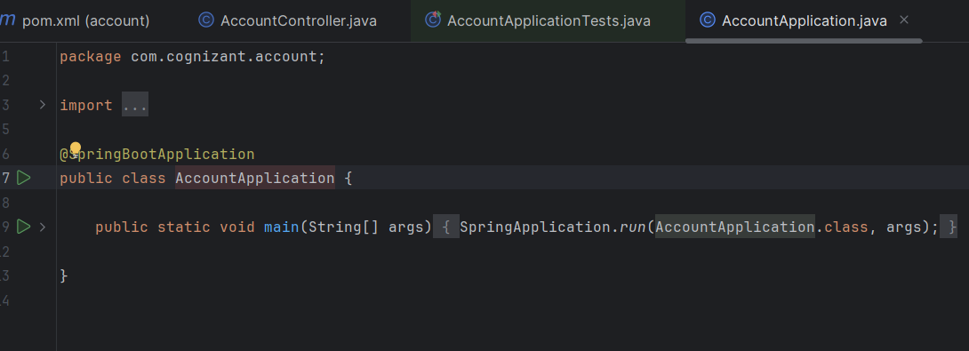Step 3) Run the Account Microservice i.e AccountApplication.java file:

Step 4) To check the output use <http://localhost:8080/accounts/00987987973432>:

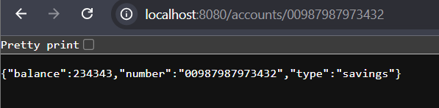

Step 5) Similar Steps for Loan Microservice upto importing the pom.xml file in new project of the IDE , then add a property in src/main/resources/application.properties of loan microservice:

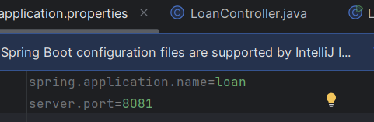

Step 6) Create a LoanController class in Loan microservice:

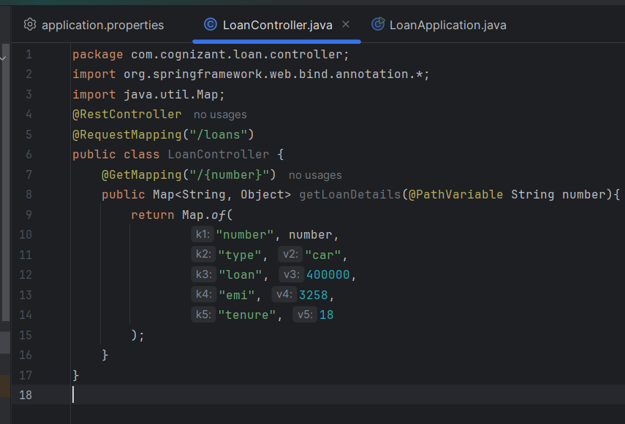

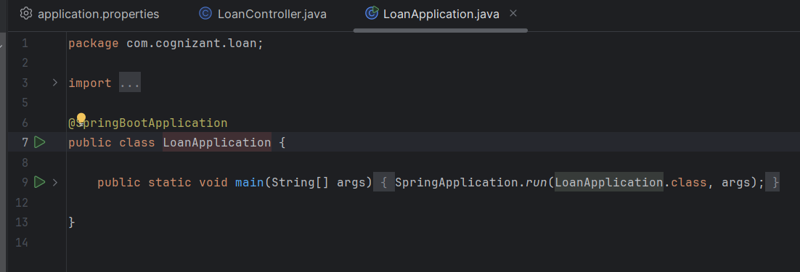Step 7) Run the Loan Microservice i.e LoanApplication.java file:

Step 8) To view the output use on port 8081:

<http://localhost:8081/loans/H00987987972342>

